TELECOM DATA ANALYSIS PROJECT

# HOME PAGE

In Home page used button to get details of Revenue Analysis, Top plan details and Market Shares(crtl+Enter) to get to the perspective page

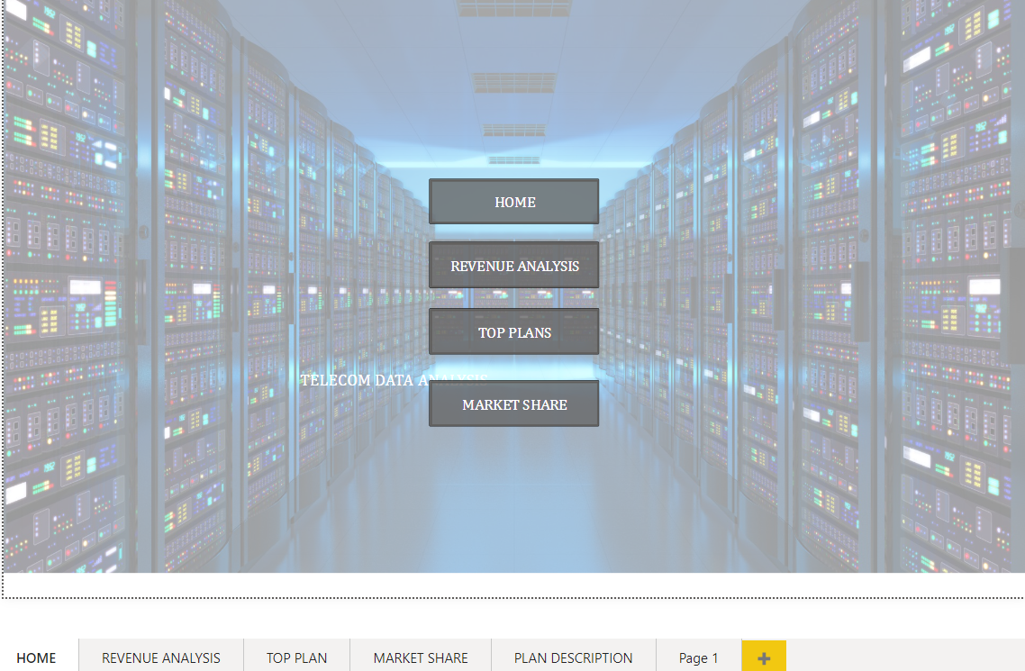

# REVENUE ANALYSIS PAGE

In Revenue page added total revenue ARPU(Average Revenue Per User),Monthly Active User and Monthly how many user unsubscribed

In tables mentioned every evaluation before and after 5G evolution and the Graphs showing the difference for after and before 5G based on month wise

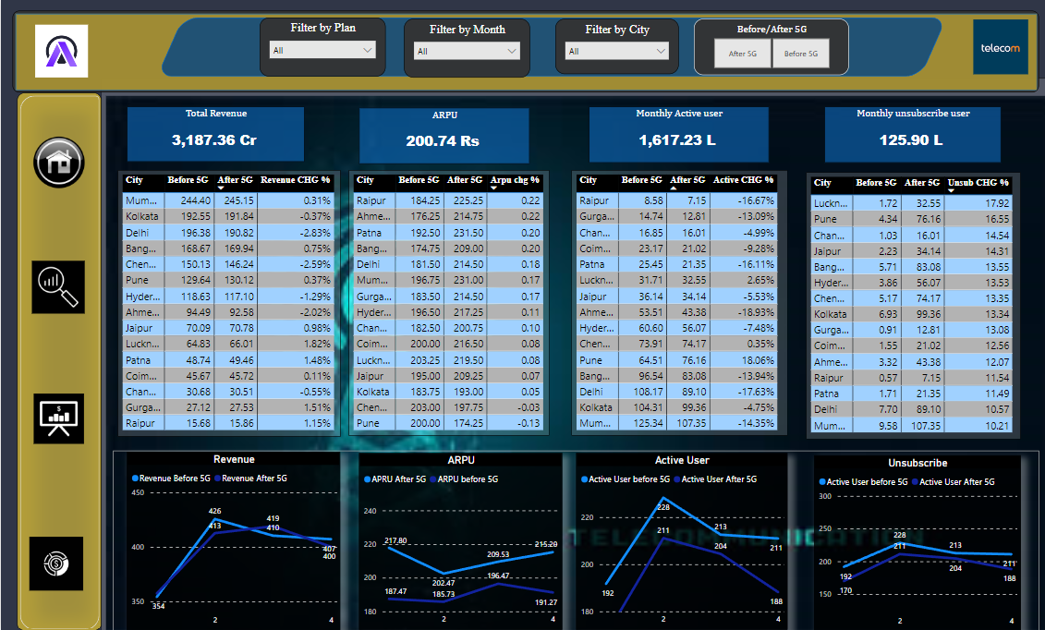

# TOP PLANS

In Top plans, how much revenue received

In table for every plan how much over all revenue and before and after 5g how much deviation is happened the details and mentioned

In graph, revenue based on before and after 5g and revenue based on cities and Top 5 plan based on revenue and low plan based on revenue

Using filter we can minimize the insights

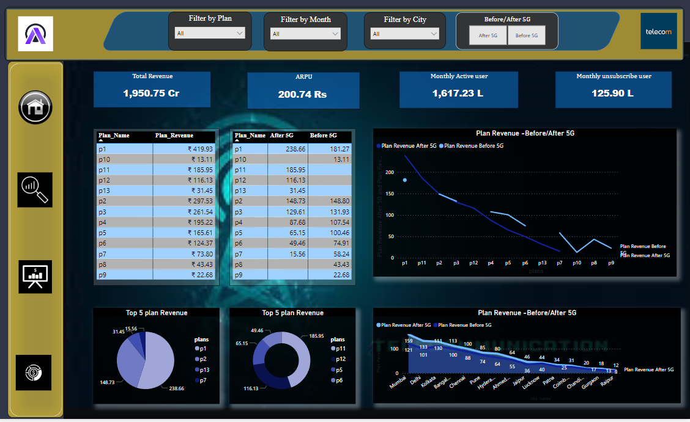

Each plan having description , using tooltip the details are described

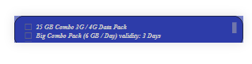

# MARKET SHARE

Based on internet user the revenue is calculating here and how much share increase based on company

Revenue by city before and after and over all revenue and Market share based on company and before and after market share

